Field Trip Report: Visit to Krishi Vigyan Kendra (KVK), Rastakuntubai

**Date:** 30th August 2024  
**Venue:** Krishi Vigyan Kendra (KVK), Rastakuntubai  
**Organized by:** Department of Mathematics  
**Participants:** 25 Students (First Year B.Sc. Computer Science), Faculty Members

As part of the **Induction Programme** for first-year students, the **Department of Mathematics** organized a **field trip to Krishi Vigyan Kendra (KVK), Rastakuntubai** on **30th August 2024**. This educational trip aimed to expose students to the practical applications of mathematics and science in agriculture and rural development.

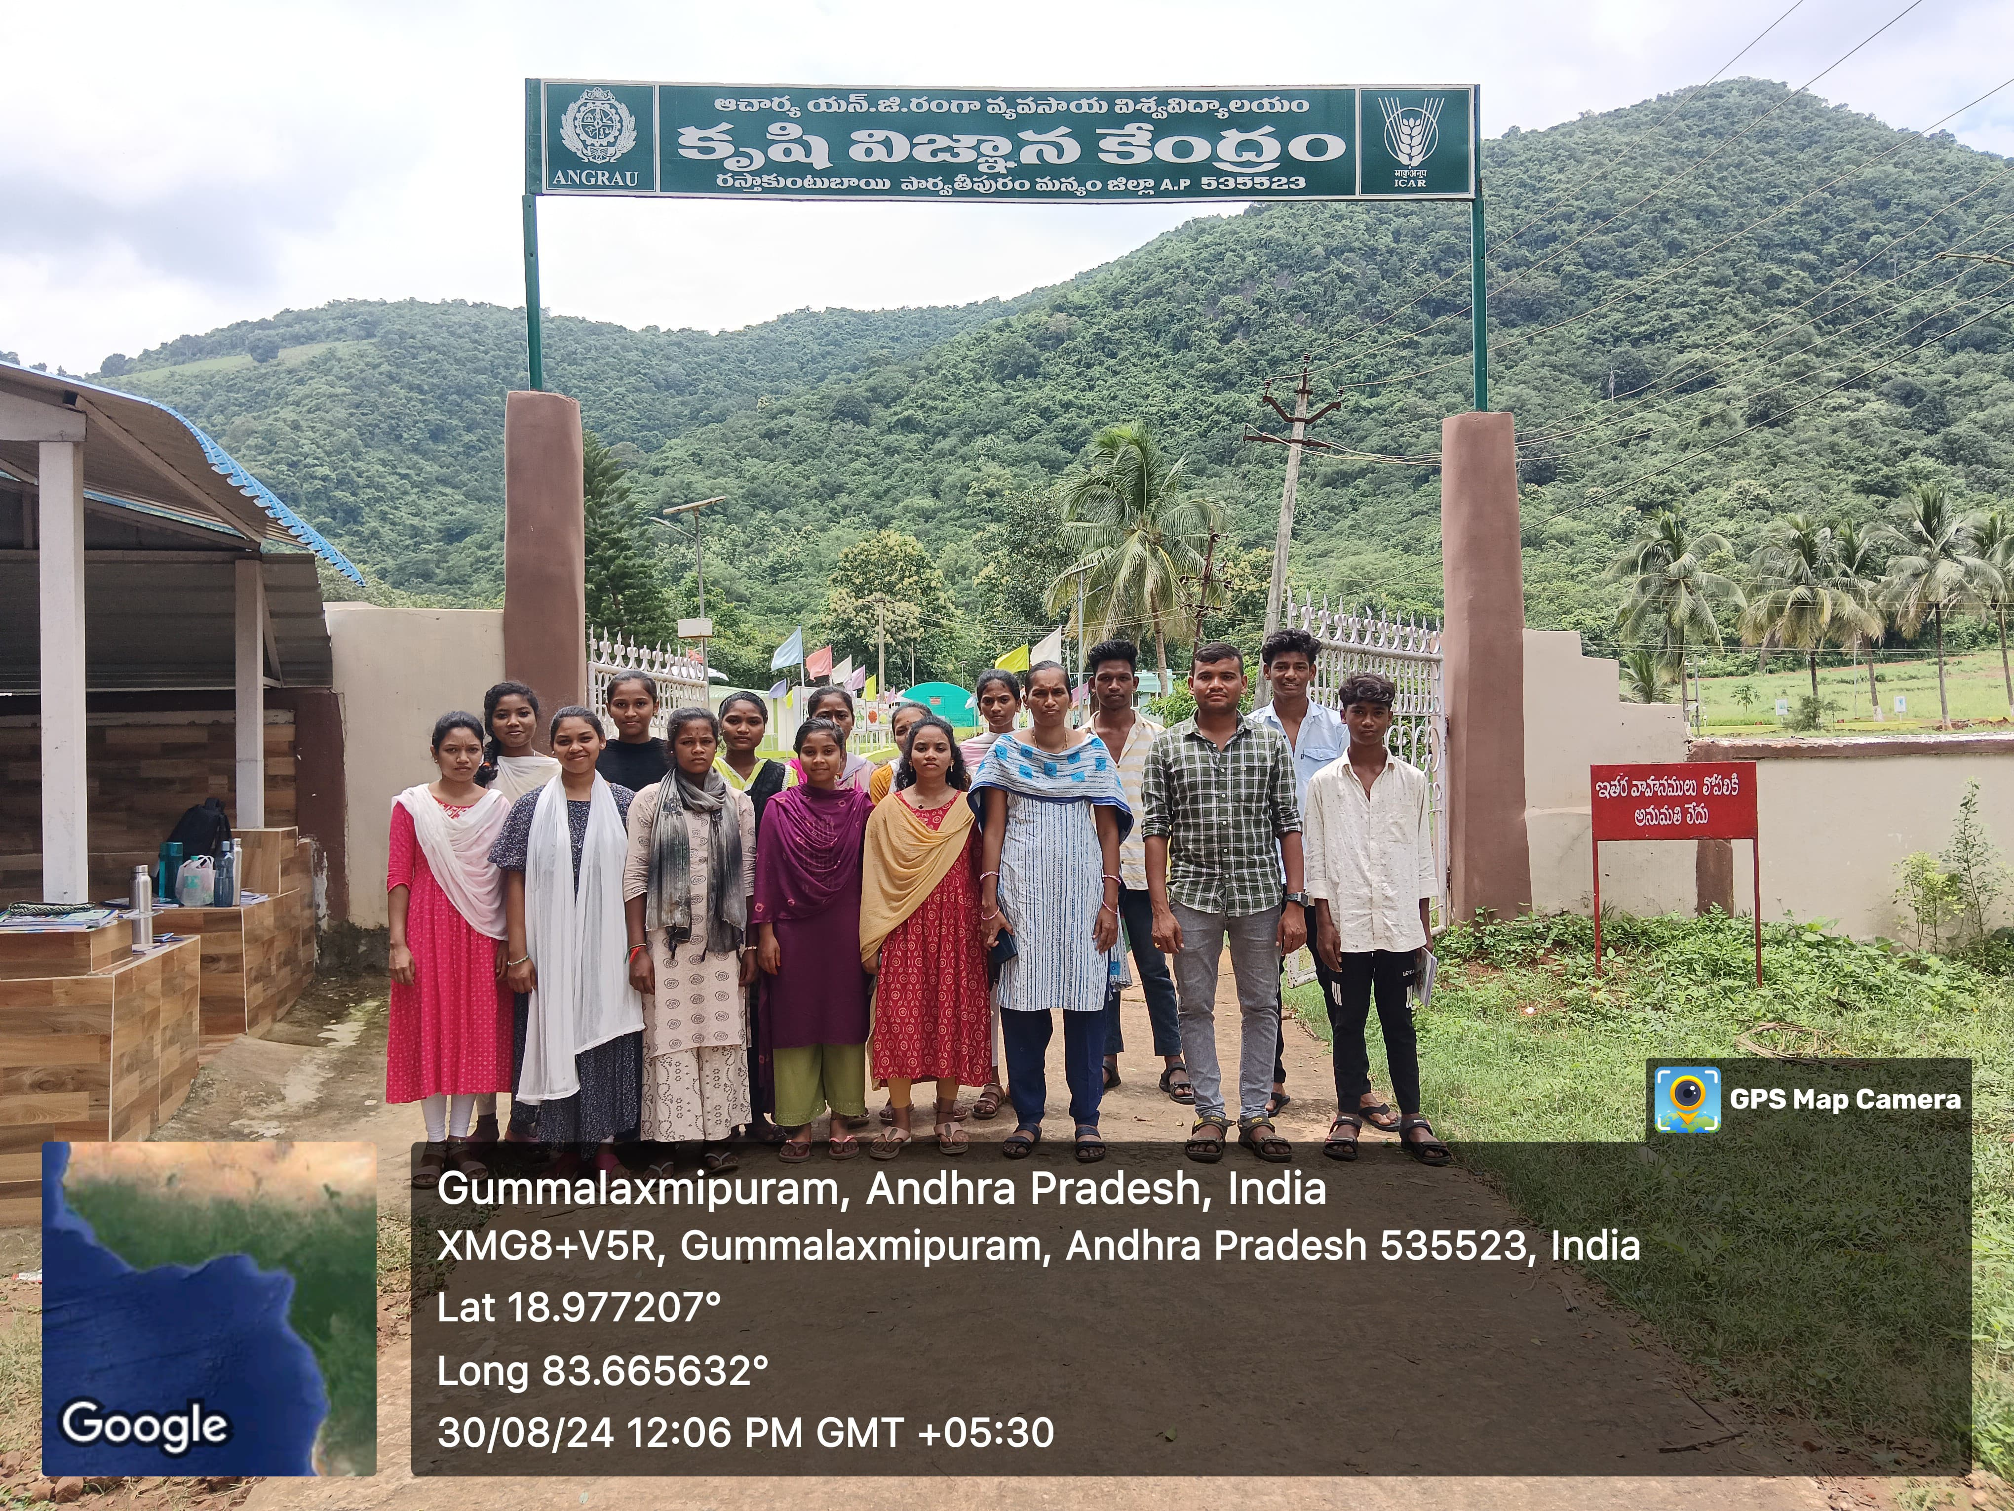

The visit was conducted under the guidance of **Mathematics faculty members**, accompanied by **Sri Srikanth, Lecturer in Physics**. A total of **25 students** from **first-year B.Sc. Computer Science** actively participated in this academic trip.

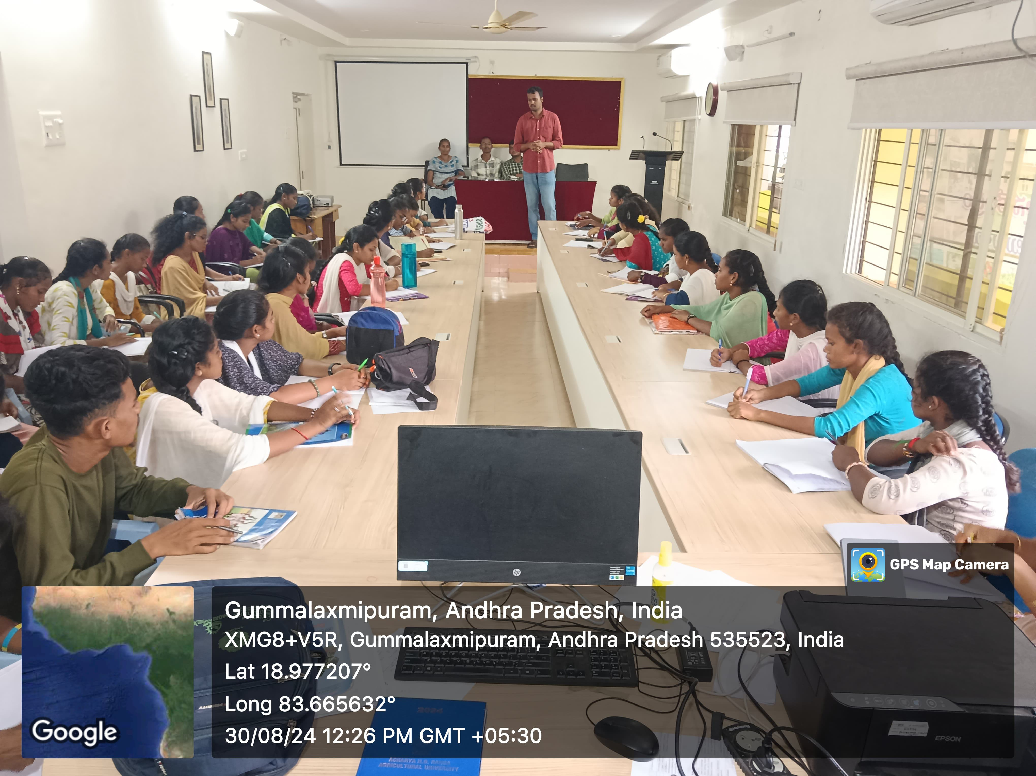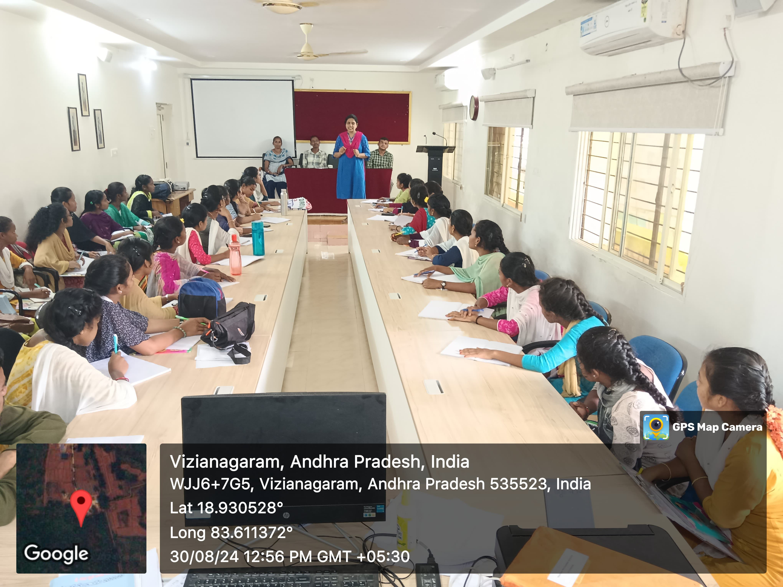

At KVK, students were introduced to various innovative agricultural practices, including modern irrigation systems, crop yield estimation, data collection techniques, and the use of mathematical modeling in weather forecasting and farm planning. The KVK resource personnel also shared insights on sustainable agriculture, soil health management, and the role of data analysis in decision-making.

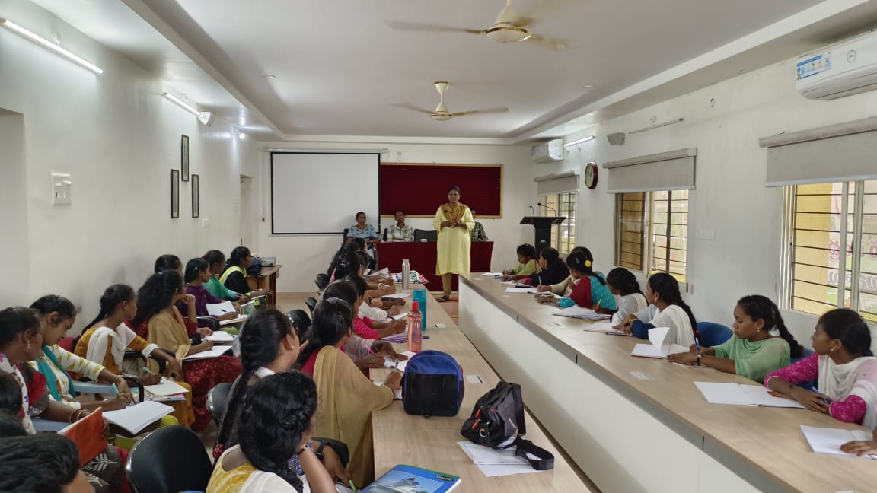

The field trip served as a valuable experience for students to understand the **real-life applications of mathematics and science** in agricultural technology. It also encouraged interdisciplinary learning by linking core mathematical concepts with environmental and technological solutions in agriculture.

The program concluded with an interactive Q&A session, where students clarified their doubts and shared feedback about their learning. The trip was a great success in enhancing students’ curiosity, practical knowledge, and appreciation of the interconnectedness of disciplines.